**Python FPFE - Instructions**

1. Downloading Python

* Download Python 2.7 version (64-Bit Installer) at the following site <https://www.continuum.io/downloads>

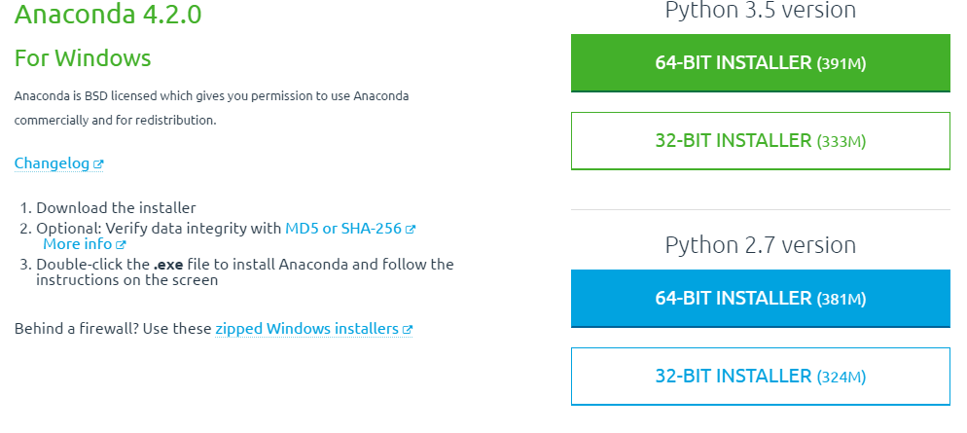

* Run the Installer

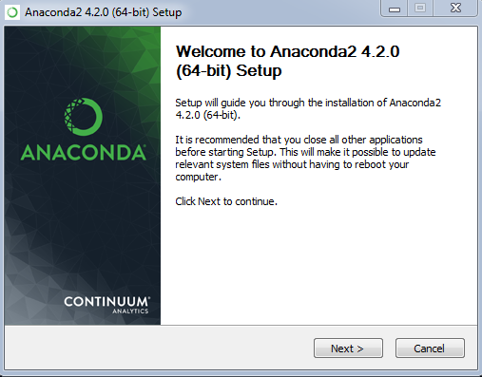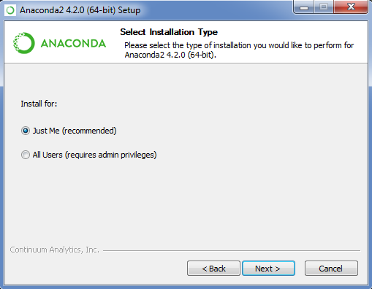

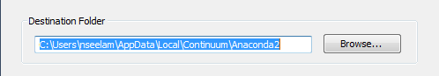

* Default folder and Recommended Installation settings are fine.

1. Accessing Python Scripts

* Request access to the FiOps Python Scripts Box Folder
* Sync FiOps Python Scripts to your computer.

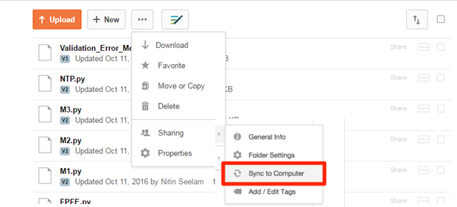

* Save a copy of the *FPFE.bat* file found in the following folder to your desktop:

S:\Finance Operations\SQL Files\FiOps Analytics

* Please open *Python Packages Install.bat* file and allow it to run.
  + This file will automatically open a Windows prompt and runs few lines of code.
  + This is an essential part as it install packages that are necessary to run the core FPFE scripts.
  + Once it is ran, it does not have to be ran again, unless errors pop up during the install
  + Inform Box Folder Owners if an error persists.

1. Using the FPFE

* Double click on *FPFE.bat* file to Launch the FPFE Python Program

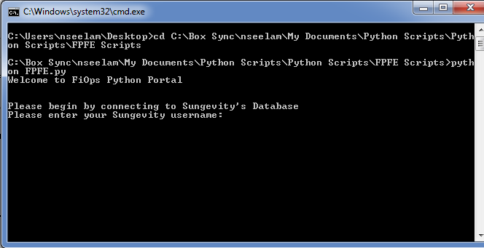

* FPFE process begins by connecting to Sungevity’s Database
  + Enter your Sungevity username followed by your Database Password, provided by IT.

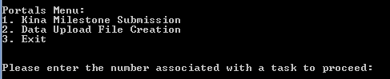

* Next, select one of the available tasks to proceed
  + Currently available: Kina Milestone Submission.

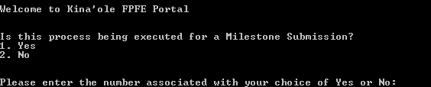

* Enter “1” or “2” to answer if you are executing the Python scripts for an actual Milestone Submission
  + Choosing 1. Yes, saves the Submission file to the S Drive. Choosing 2. No saves Submission file to user’s desktop.
  + Path of saved file will be displayed towards the end.

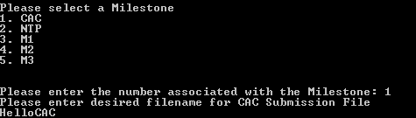

* Enter number associated with Milestone conducting the FPFE for.
* Enter desired filename for the output.
* Will take a few seconds to a minutes (depending on status of Database), before the final Submission File is created and saved.



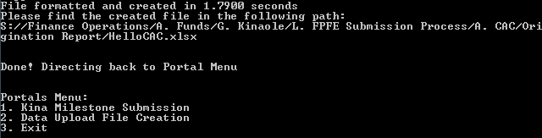

* Path where Submission File is saved is printed
* Details regarding query and file creation time are provided
* Lastly, user is directed back to home menu, where another task can be conducted or user can exit the program.